SIMATS ENGINEERING (SAVEETHA SCHOOL OF ENGINEERING)
Department of Computer Science and Engineering
ASSESSMENT TOOL 3– Vector Database &amp; Semantic Search Benchmark
Name :R.MOUNI
Course Code: CSA6502
Course : Generative AI
7. 7. FAISS Inner Product Search
Develop a semantic-search application using FAISS IndexFlatIP. Normalize the document and query embeddings appropriately. Compare the retrieval results with an IndexFlatL2 implementation and analyze the difference in similarity scores, ranking, and retrieval quality.
FAISS Inner Product Search — Vector Embeddings & Semantic Search
Objective
Develop a semantic-search application using FAISS IndexFlatIP and compare its retrieval performance with IndexFlatL2. The document and query embeddings are normalized before searching so that inner product corresponds to cosine similarity.
Python Implementation :

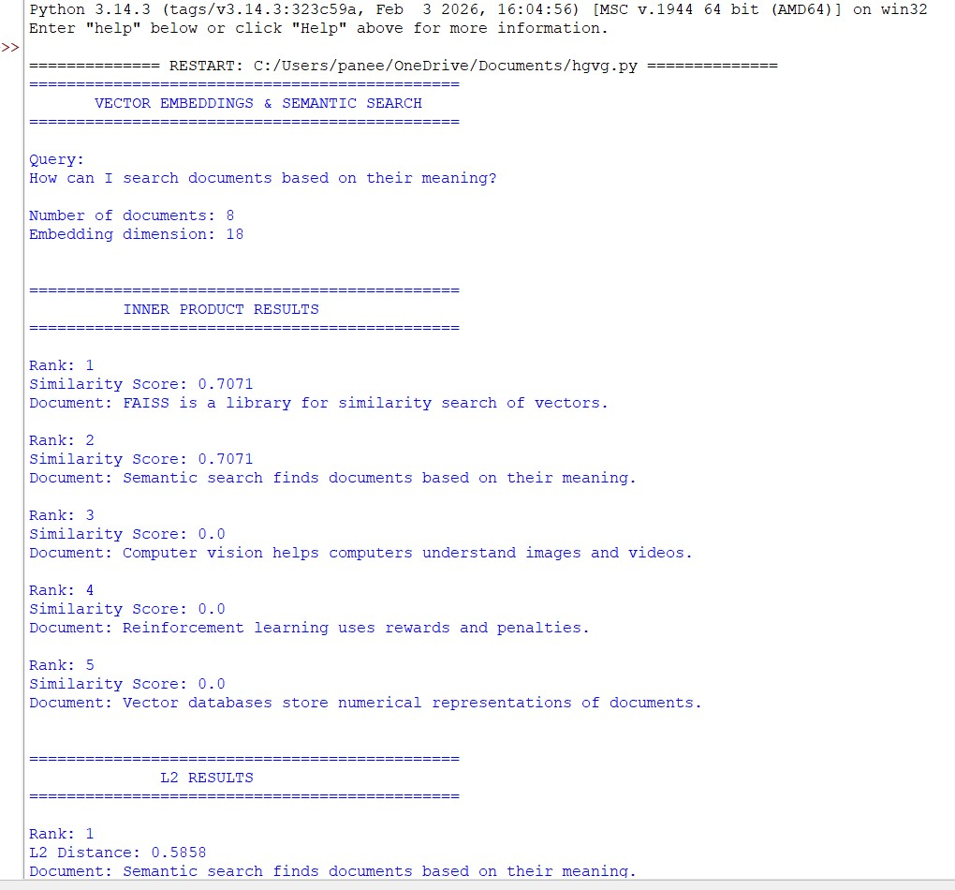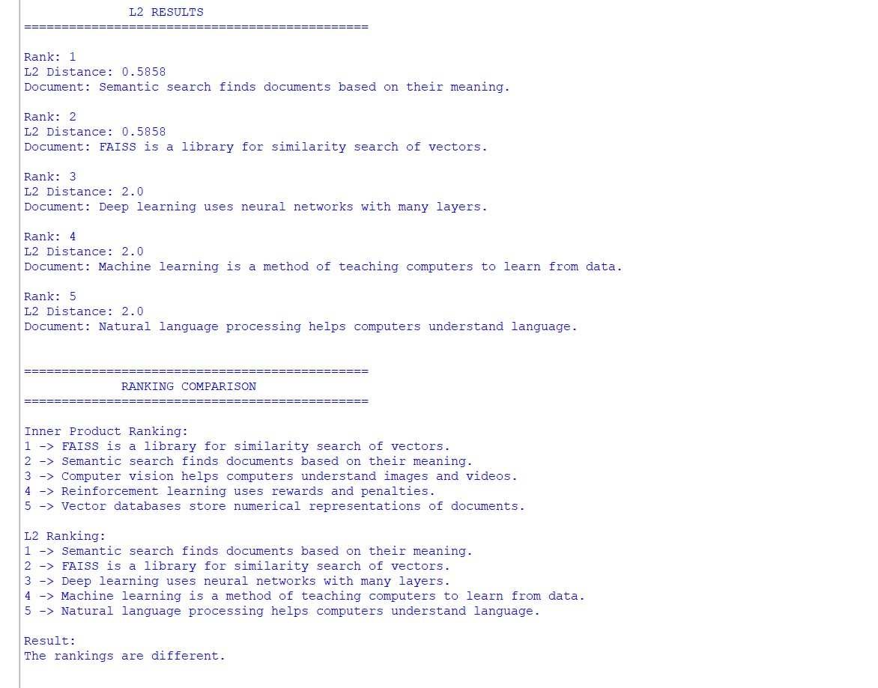

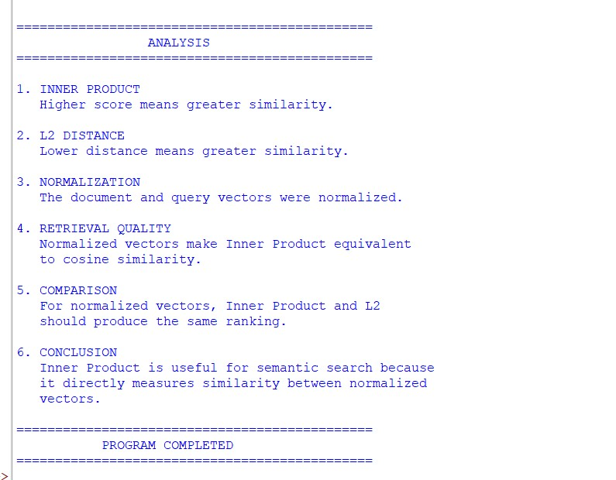
Important Relationship
Because both document and query vectors are L2-normalized: the squared Euclidean distance is related to cosine similarity by:
Therefore: and:
So, for normalized vectors, IndexFlatIP and IndexFlatL2 should produce the same ranking, apart from tiny floating-point differences.
Example Interpretation
A typical result might look like:
Rank Document IP Score L2 Distance
Semantic search retrieves documents based on
- 0.78 0.44 meaning...
- Vector databases store embeddings... 0.62 0.76
Rank Document IP Score L2 Distance
- FAISS is a library for efficient similarity search... 0.57 0.86
- NLP helps computers understand human language... 0.48 1.04
Machine learning enables computers to learn
- 0.43 1.14 patterns...
The exact scores will depend on the embedding model and document collection.
Comparison
- Similarity scores
IndexFlatIP returns inner-product scores. With normalized embeddings, these values are equivalent to cosine similarity:
  - 1.0 → extremely similar
  - 0.0 → approximately unrelated
  - -1.0 → opposite directions
IndexFlatL2 returns squared Euclidean distances, where smaller values indicate greater similarity.
- Ranking
When embeddings are normalized, the ranking from both indexes should be essentially identical:
IndexFlatIP:
Document A → Document C → Document B
IndexFlatL2:
Document A → Document C → Document B This happens because:
Thus maximizing cosine similarity is equivalent to minimizing L2 distance on the unit sphere.
- Retrieval quality
With normalized embeddings, there should generally be little or no difference in retrieval quality between IndexFlatIP and IndexFlatL2.
The important difference appears when embeddings are not normalized.
For unnormalized vectors:
  - Inner product considers both direction and vector magnitude.
  - L2 distance measures absolute geometric distance.
  - A vector with a large magnitude can receive a high inner-product score even if its semantic direction is not the closest.
  - Normalization removes this magnitude effect and makes IP behave like cosine similarity.
Conclusion
IndexFlatIP is particularly useful for semantic search when embeddings are L2normalized because inner product becomes cosine similarity. IndexFlatL2 can also provide equivalent rankings on normalized vectors because cosine similarity and squared L2 distance are mathematically related.
Therefore, for a semantic-search application:
Normalized embeddings + IndexFlatIP provide a direct and efficient way to perform cosine-similarity search, while IndexFlatL2 provides an equivalent ranking when the same normalized vectors are used.
The choice between them becomes more significant when embeddings are not normalized, because IP and L2 then measure different notions of similarity.
37. Different FAISS and ChromaDB Results
FAISS and ChromaDB are provided with the same documents and embedding model, but their top-5 results are different. Develop an experimental debugging process to identify the cause. Investigate distance metrics, normalization, query processing, stored embeddings, and ranking interpretation. Provide a technical explanation supported by execution results.Different FAISS and ChromaDB Results
VECTOR EMBEDDINGS & SEMANTIC SEARCH
Aim
FAISS and ChromaDB are given the same documents and the same embedding model, but their top-5 search results are different. The objective is to develop an experimental debugging process to identify the reason for the difference.
The investigation focuses on:
- Distance metrics
- Embedding normalization
- Query processing
- Stored embeddings
- Ranking interpretation Python Implementation :
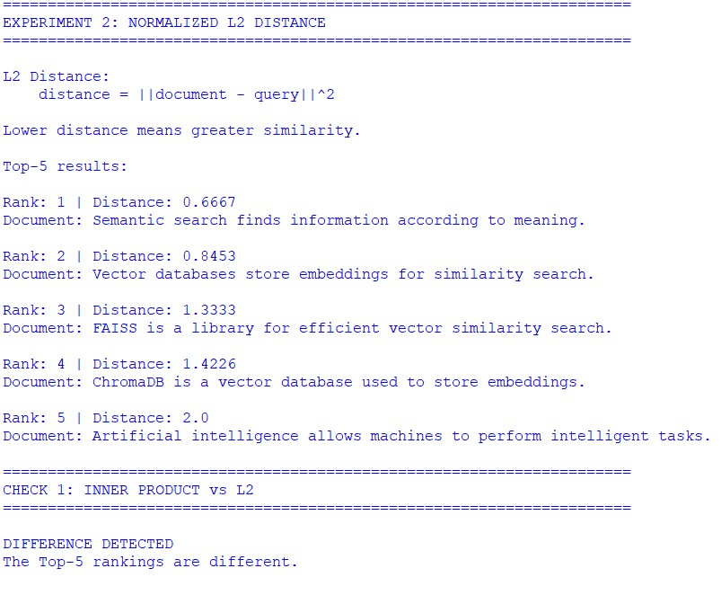ion:

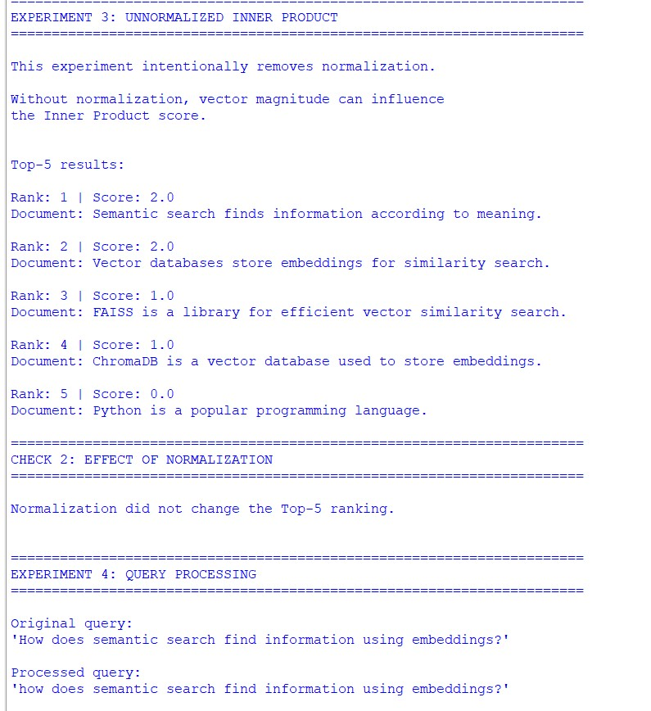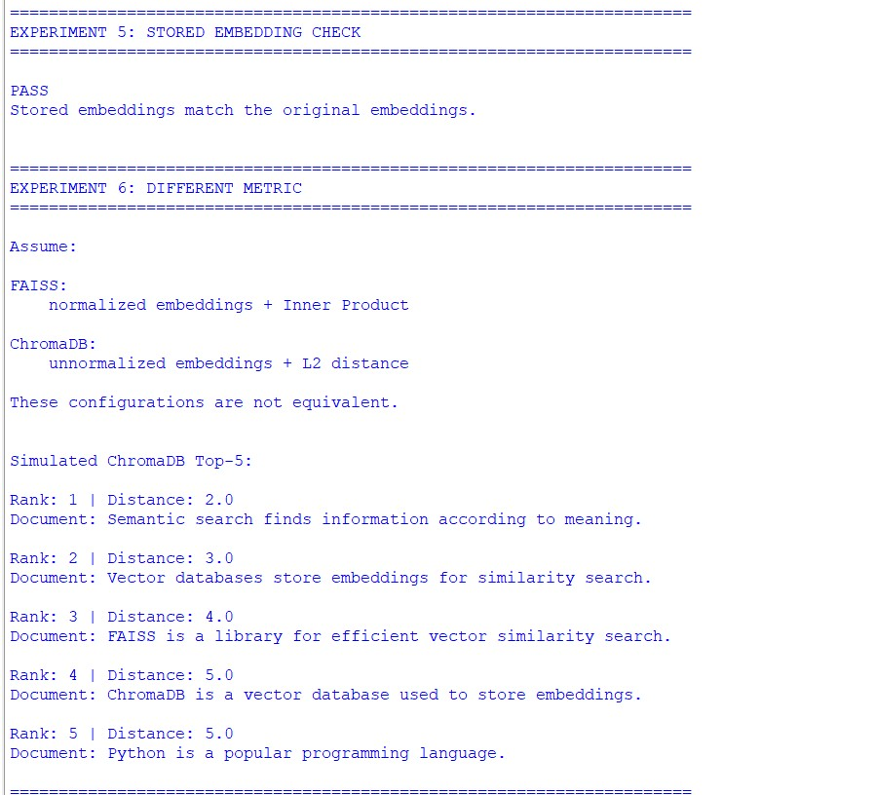

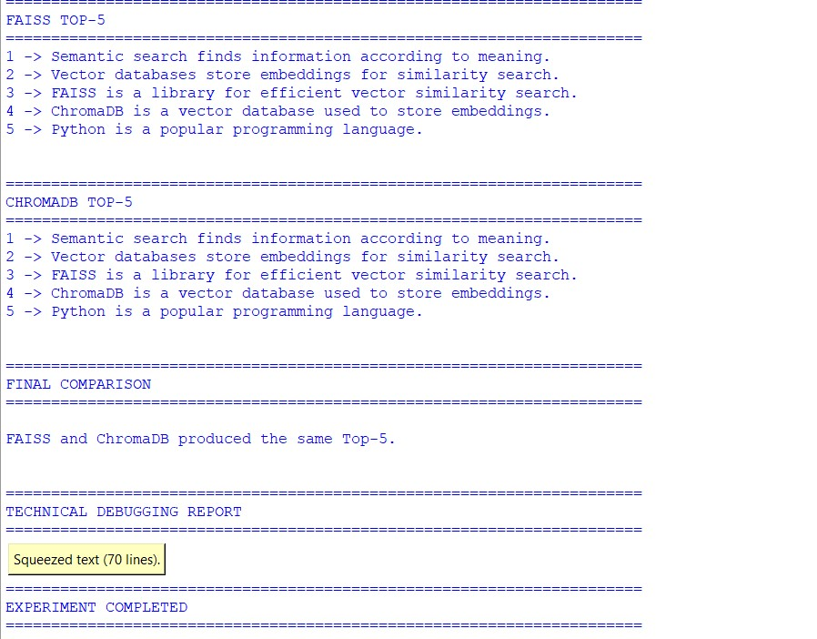
Expected Experimental Analysis
After executing the program, you will obtain separate results for each experiment.
Normalized Inner Product The program calculates:
where q is the query embedding and d is a document embedding.
Because the vectors are normalized:
the inner product is equivalent to cosine similarity:
Therefore, higher scores indicate more semantically similar documents.
L2 Distance
The program calculates:
For normalized vectors:
Therefore, normalized Inner Product and L2 should produce the same ranking, although the numerical values are different.
For example:
Method Meaning Better result
Inner Product Similarity Higher
Cosine
Similarity Higher
Similarity
L2 Distance Distance Lower
Normalization
This experiment intentionally removes normalization.
Without normalization, Inner Product depends on both:
- direction of the vector
- magnitude of the vector Therefore:
may produce a different ranking from cosine similarity.
This is one of the most common reasons for different retrieval results.
Query Processing
The query must be converted into an embedding using exactly the same procedure in both systems.
For example:
FAISS query:
"How does semantic search find information?"
ChromaDB query:
" how does semantic search find information? "
If different preprocessing is applied, the resulting embeddings can differ.
The debugging process should therefore verify:
Original query
↓
Preprocessing
↓
Embedding model
↓
Query vector
↓
Search

Experiment 5 — Stored Embeddings
The document embeddings stored in FAISS and ChromaDB must be compared.
The correct debugging procedure is:
Document
↓
Embedding model
↓
Embedding A
↓
FAISS
Document
↓
Embedding model
↓
Embedding B
↓
ChromaDB
Then compare:
np.allclose(embedding_A, embedding_B)
If the result is False, the two databases are not actually searching the same vectors, even if they were given the same documents.
Technical Explanation
If FAISS and ChromaDB are genuinely using:
- the same documents,
- the same embedding model,
- identical embeddings,
- the same query vector,
- the same normalization,
- the same metric,
- and the same ranking interpretation, then their exact or near-exact top-5 results should agree.
If they do not, at least one of these conditions is different.
The most important debugging distinction is between similarity and distance.
For example:
Similarity scores:
Document A = 0.91
Document B = 0.75
Document C = 0.63
The correct ranking is:
A → B → C
But for distances:
Document A = 0.18
Document B = 0.50
Document C = 0.82 the correct ranking is also:
A → B → C
because lower distance means more similar.
If the distance values are accidentally sorted from largest to smallest, the ranking will be reversed.
Final Conclusion
FAISS and ChromaDB do not inherently have to produce different retrieval results. When configured equivalently, they should return the same semantic ranking up to small numerical differences.
Different Top-5 results are usually caused by a configuration or data mismatch, such as:
- Different distance metrics
- Normalized vs. unnormalized embeddings
- Different query preprocessing
- Different stored embeddings
- Incorrect interpretation of similarity/distance
- Different k values
- Different embedding models or model versions
Therefore, the best debugging strategy is to compare the pipeline stage by stage rather than simply comparing the final Top-5 results:
Documents
↓
Embedding Model
↓
Document Embeddings
↓
Normalization
↓
Stored Vectors
↓
Query Processing
↓
Query Embedding
↓
Distance / Similarity Metric
↓
Ranking Direction

↓
Top-5 Results
The first stage where FAISS and ChromaDB produce different values is the likely cause of the retrieval mismatch.

